**Tutorial on adding Fire hazard, Faults, Landslide and Liquefaction layers in Parcel data:**

**I am using Liquefaction shape file to add it to Contra Costa County the following steps will be same for all the counties and the above-mentioned hazards.**

1. **First, Click on Select by Location:**

**Input features: County**

**Relationship: Intersection**

**Selecting features: Liquefaction**

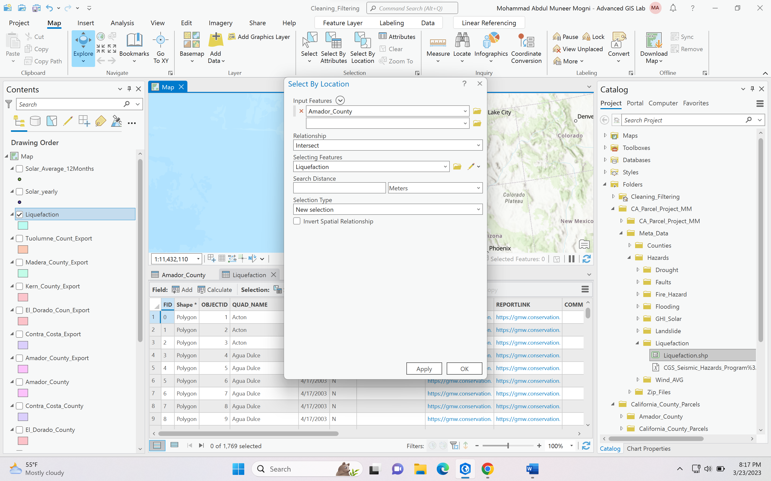

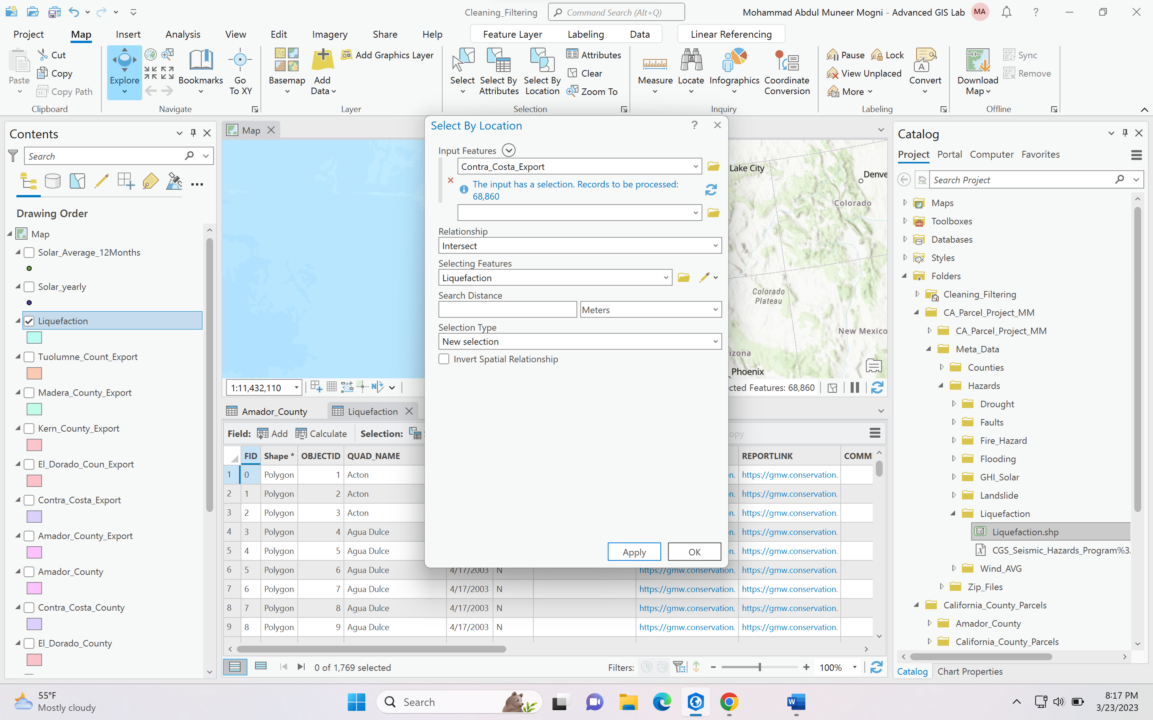

**Once it selects the records in the table close Select by location box.**

**Go to View > Geoprocessing > Calculate field:**

**Input Table: County**

**Field Name: Type “Hazard name” In my case I mentioned it as Liq**

**Scroll down Insert value box.**

**“Hazard name” = 1**

**\*Please insert 1 if it is intersecting or else insert 0 if not intersecting.**

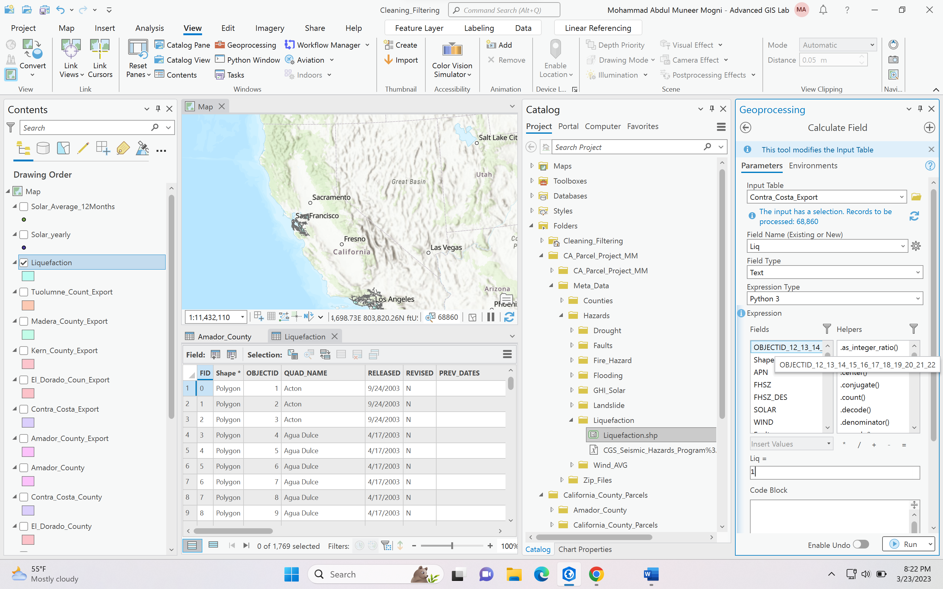

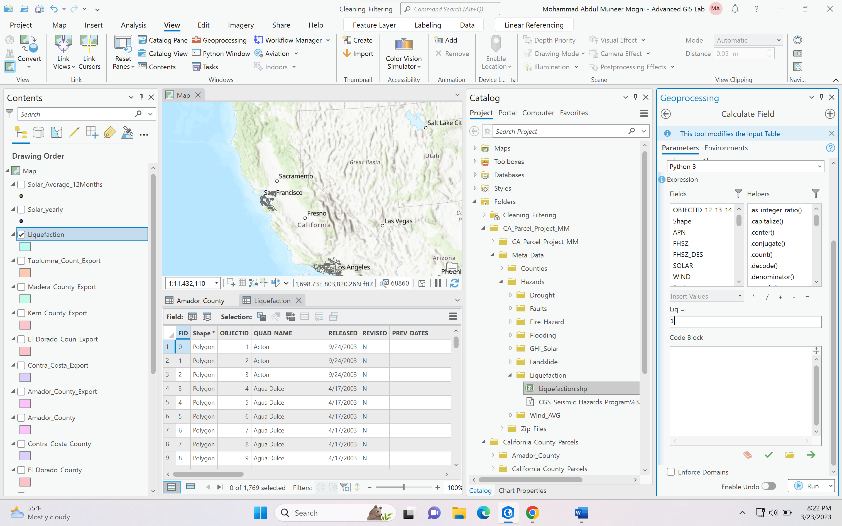

**Click Run.**

**If you observe Contra Costa County table see the last column Liq which shows only the rows which are selected by Liquefaction hazard layer and the other rows which are not selected by Liquefaction are empty or <NULL>.**

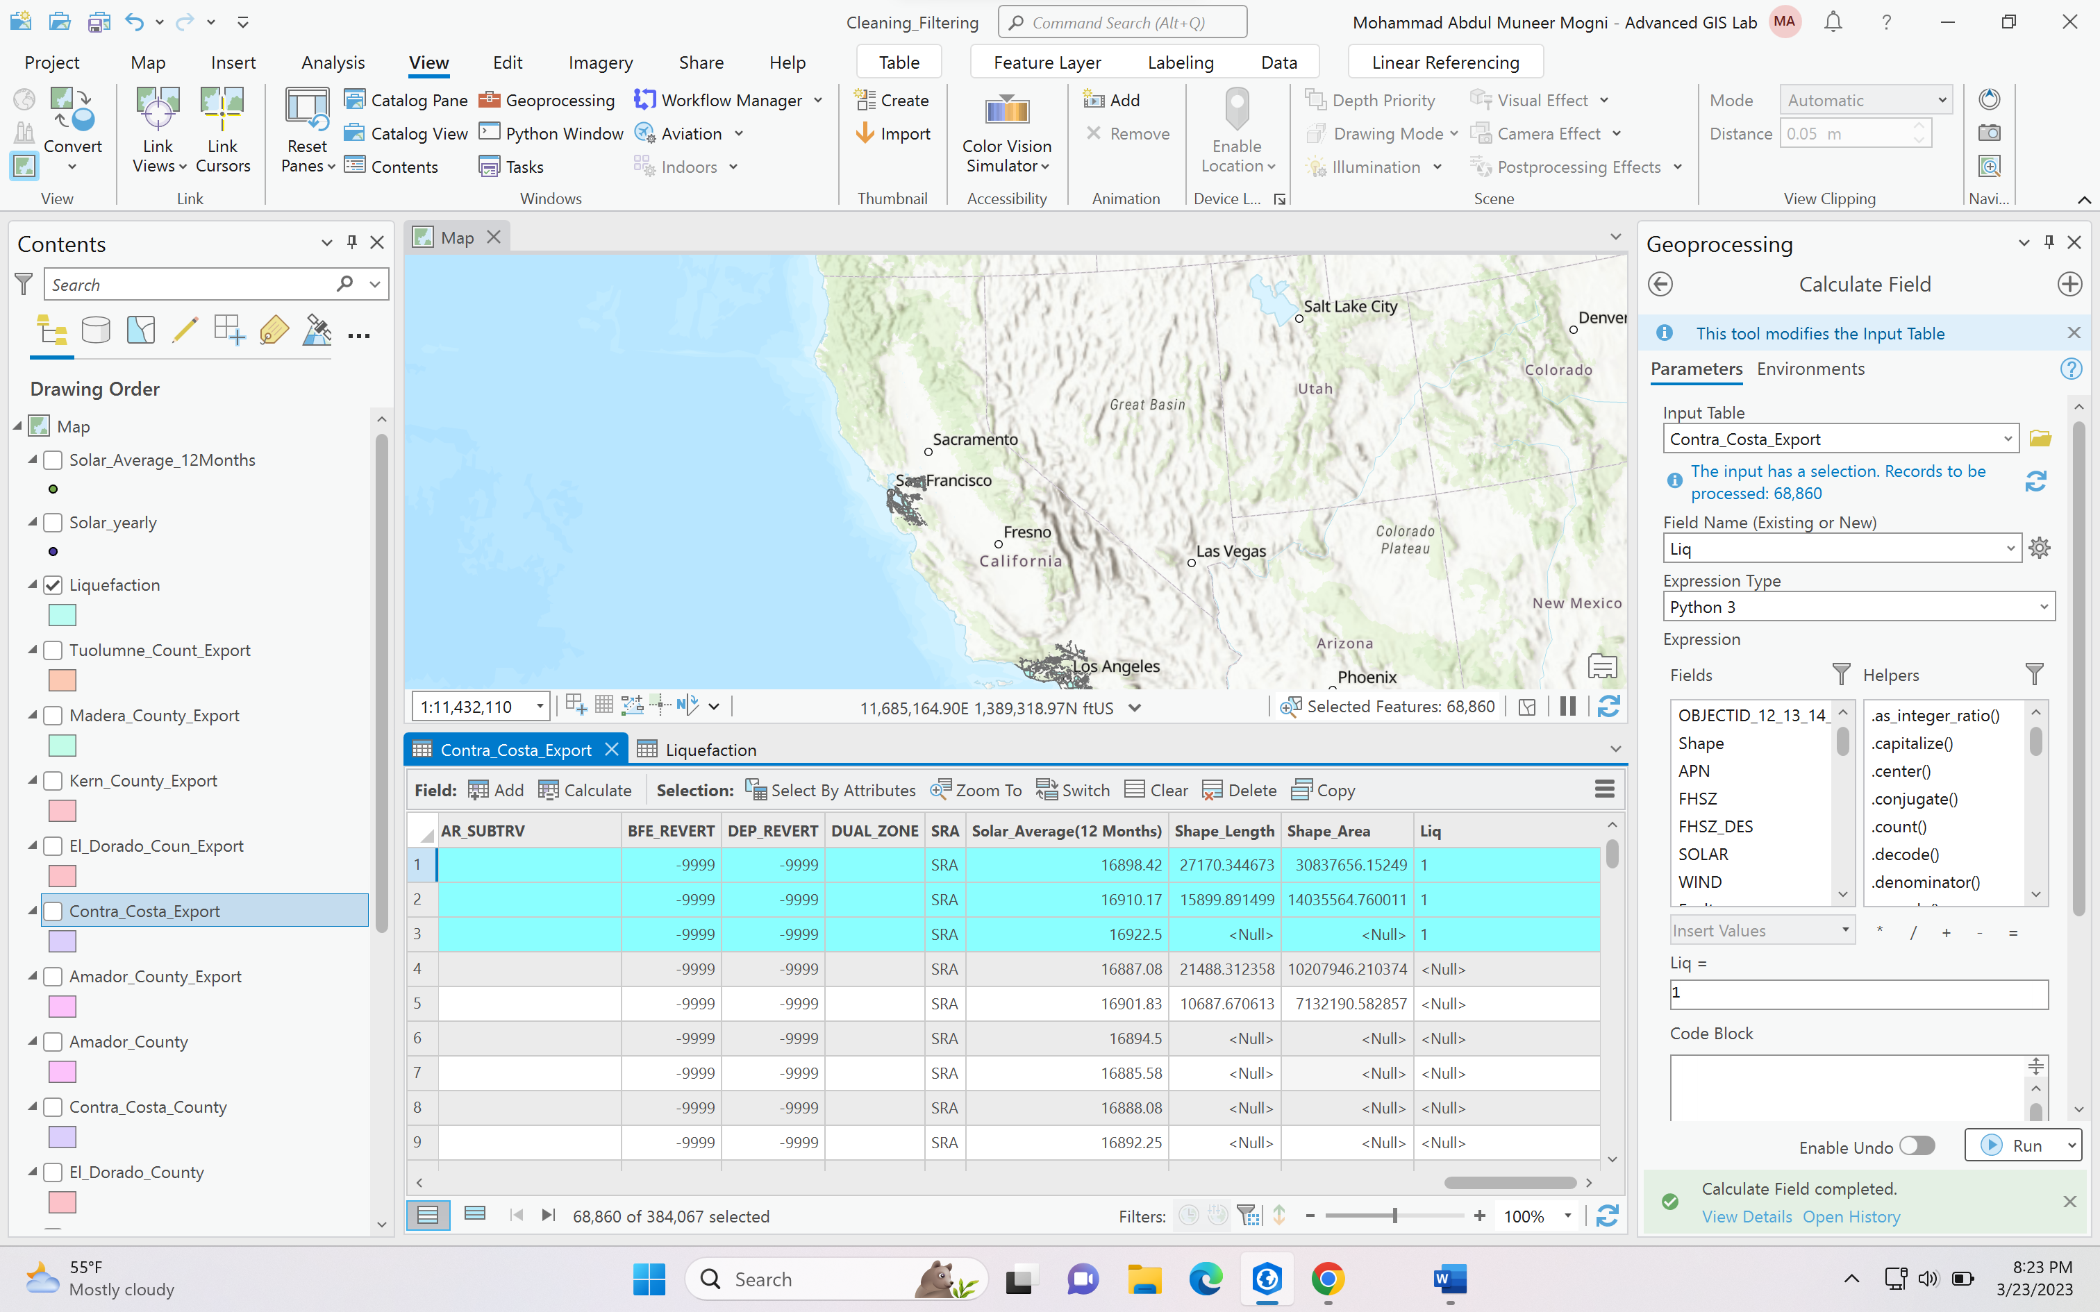

**Now to replace this NULL or empty values to zero the next step is:**

1. **Click on Map in the dashboard and clear the selected rows**

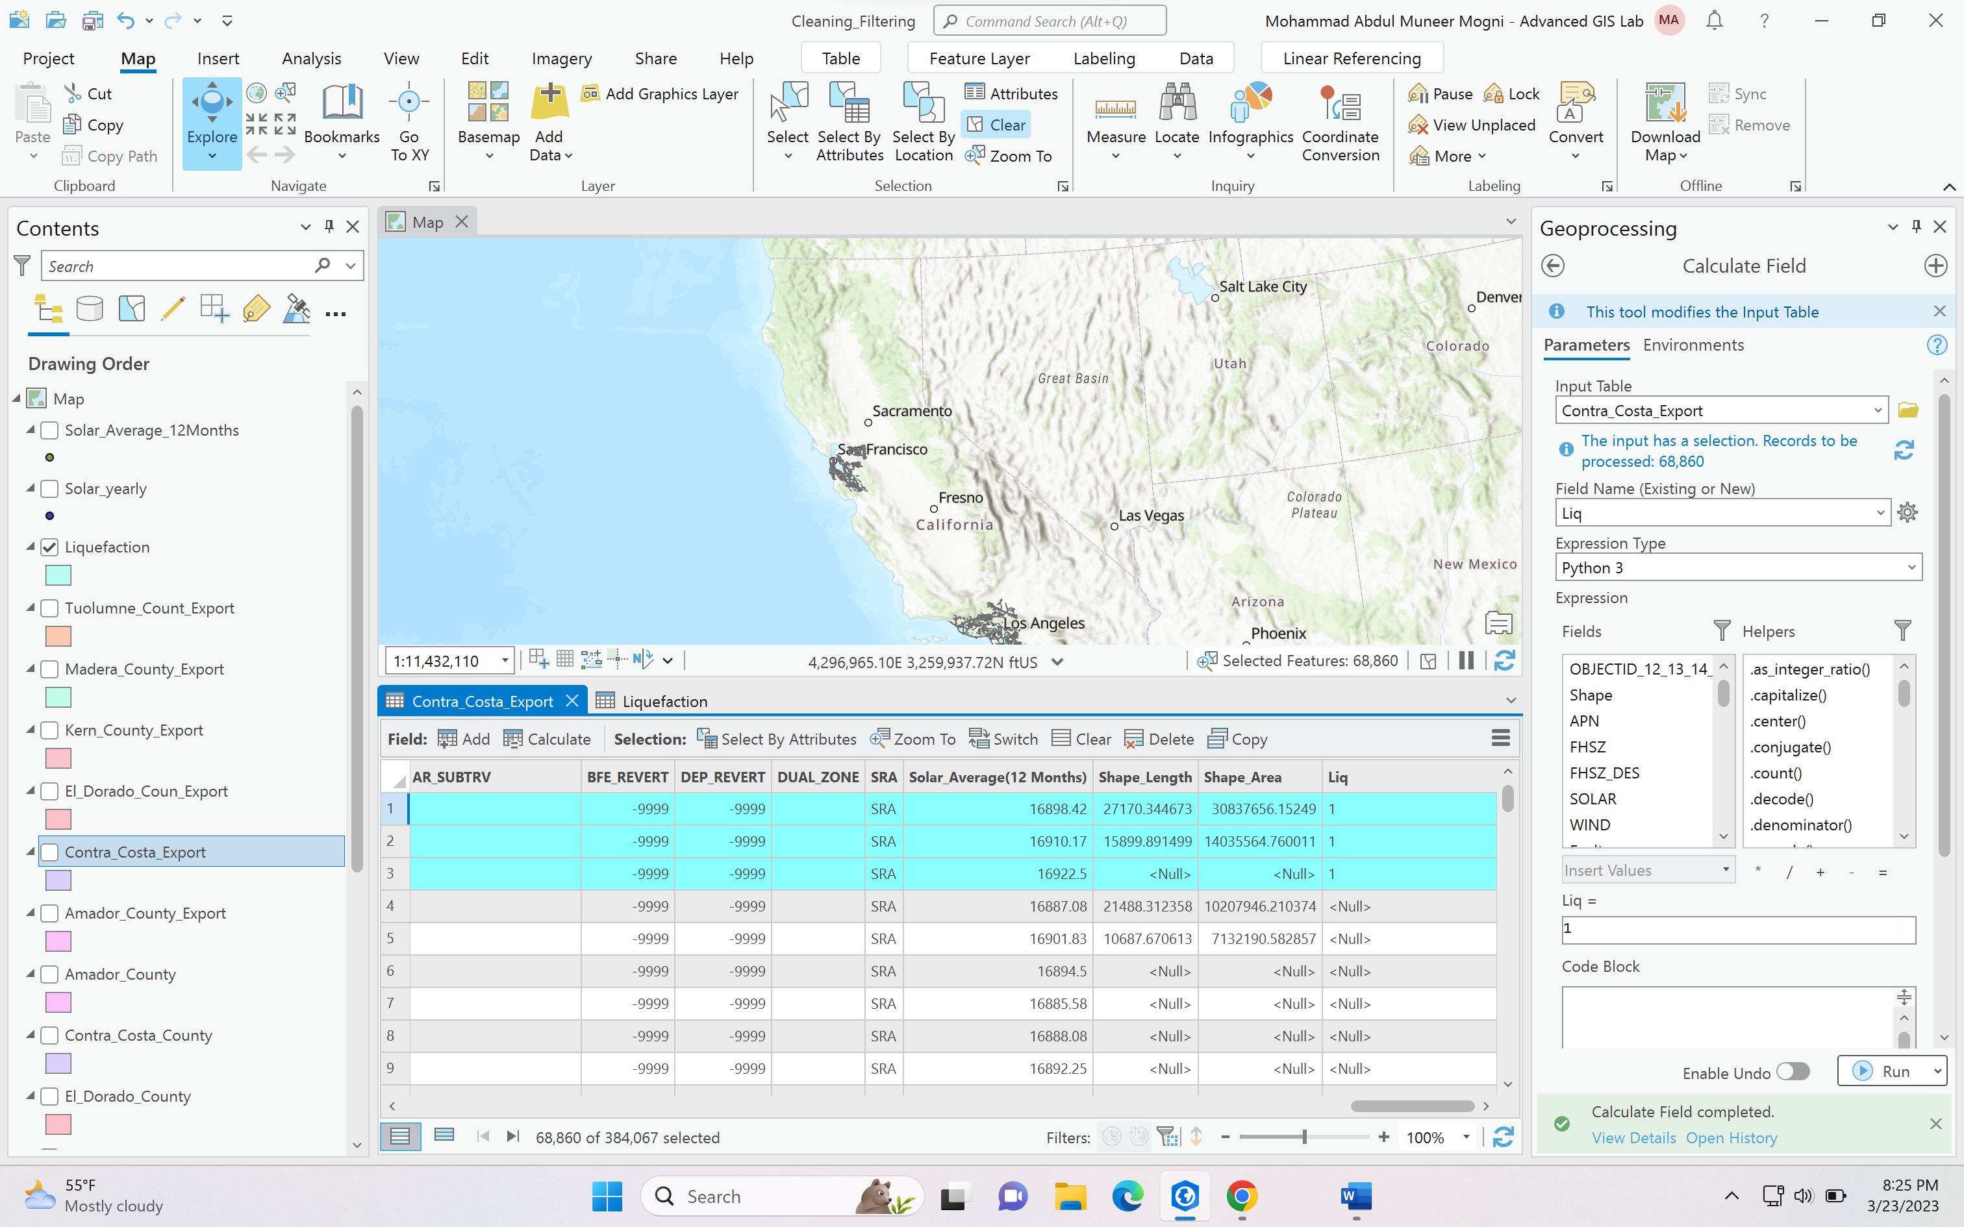

1. **Now Click on Select by Attributes**

**Input rows: County**

**Selection type: New Selection**

**Expression: Where Hazard(Liq) is not equal to 1 (Use this expression if you have empty values)**

**Expression: Where Hazard(Liq) is null (Use this expression if you have null values)**

**In my case I have null values.**

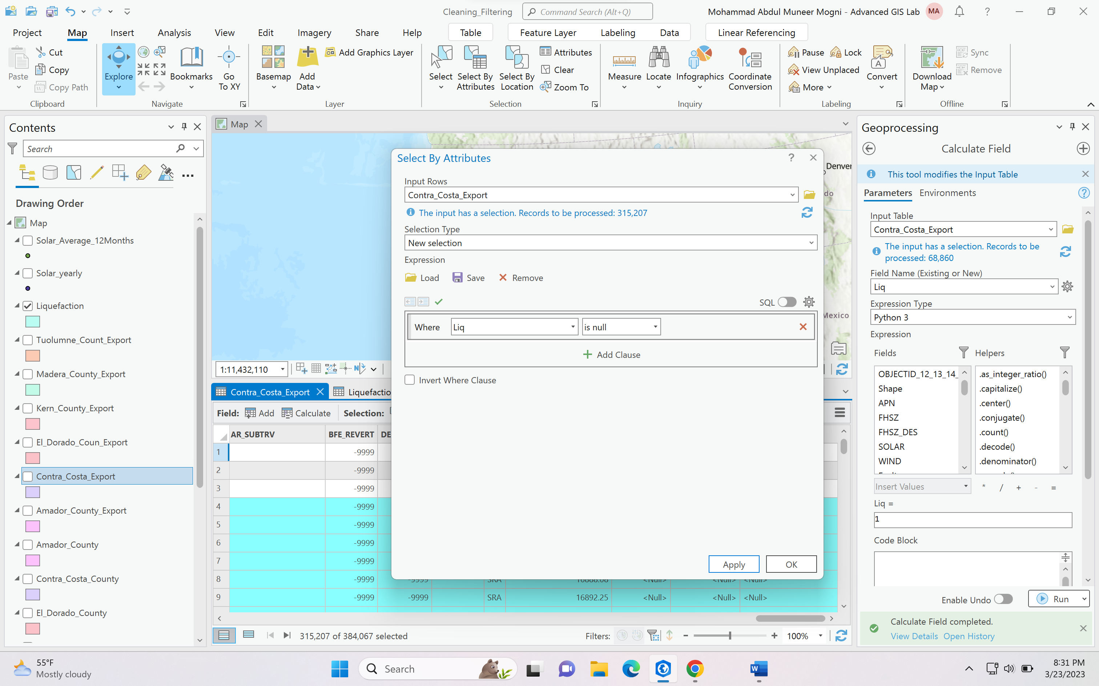

**Click on Apply**

1. **Next go to view > Geoprocessing > calculate field > select the same county (Contra Costa)**

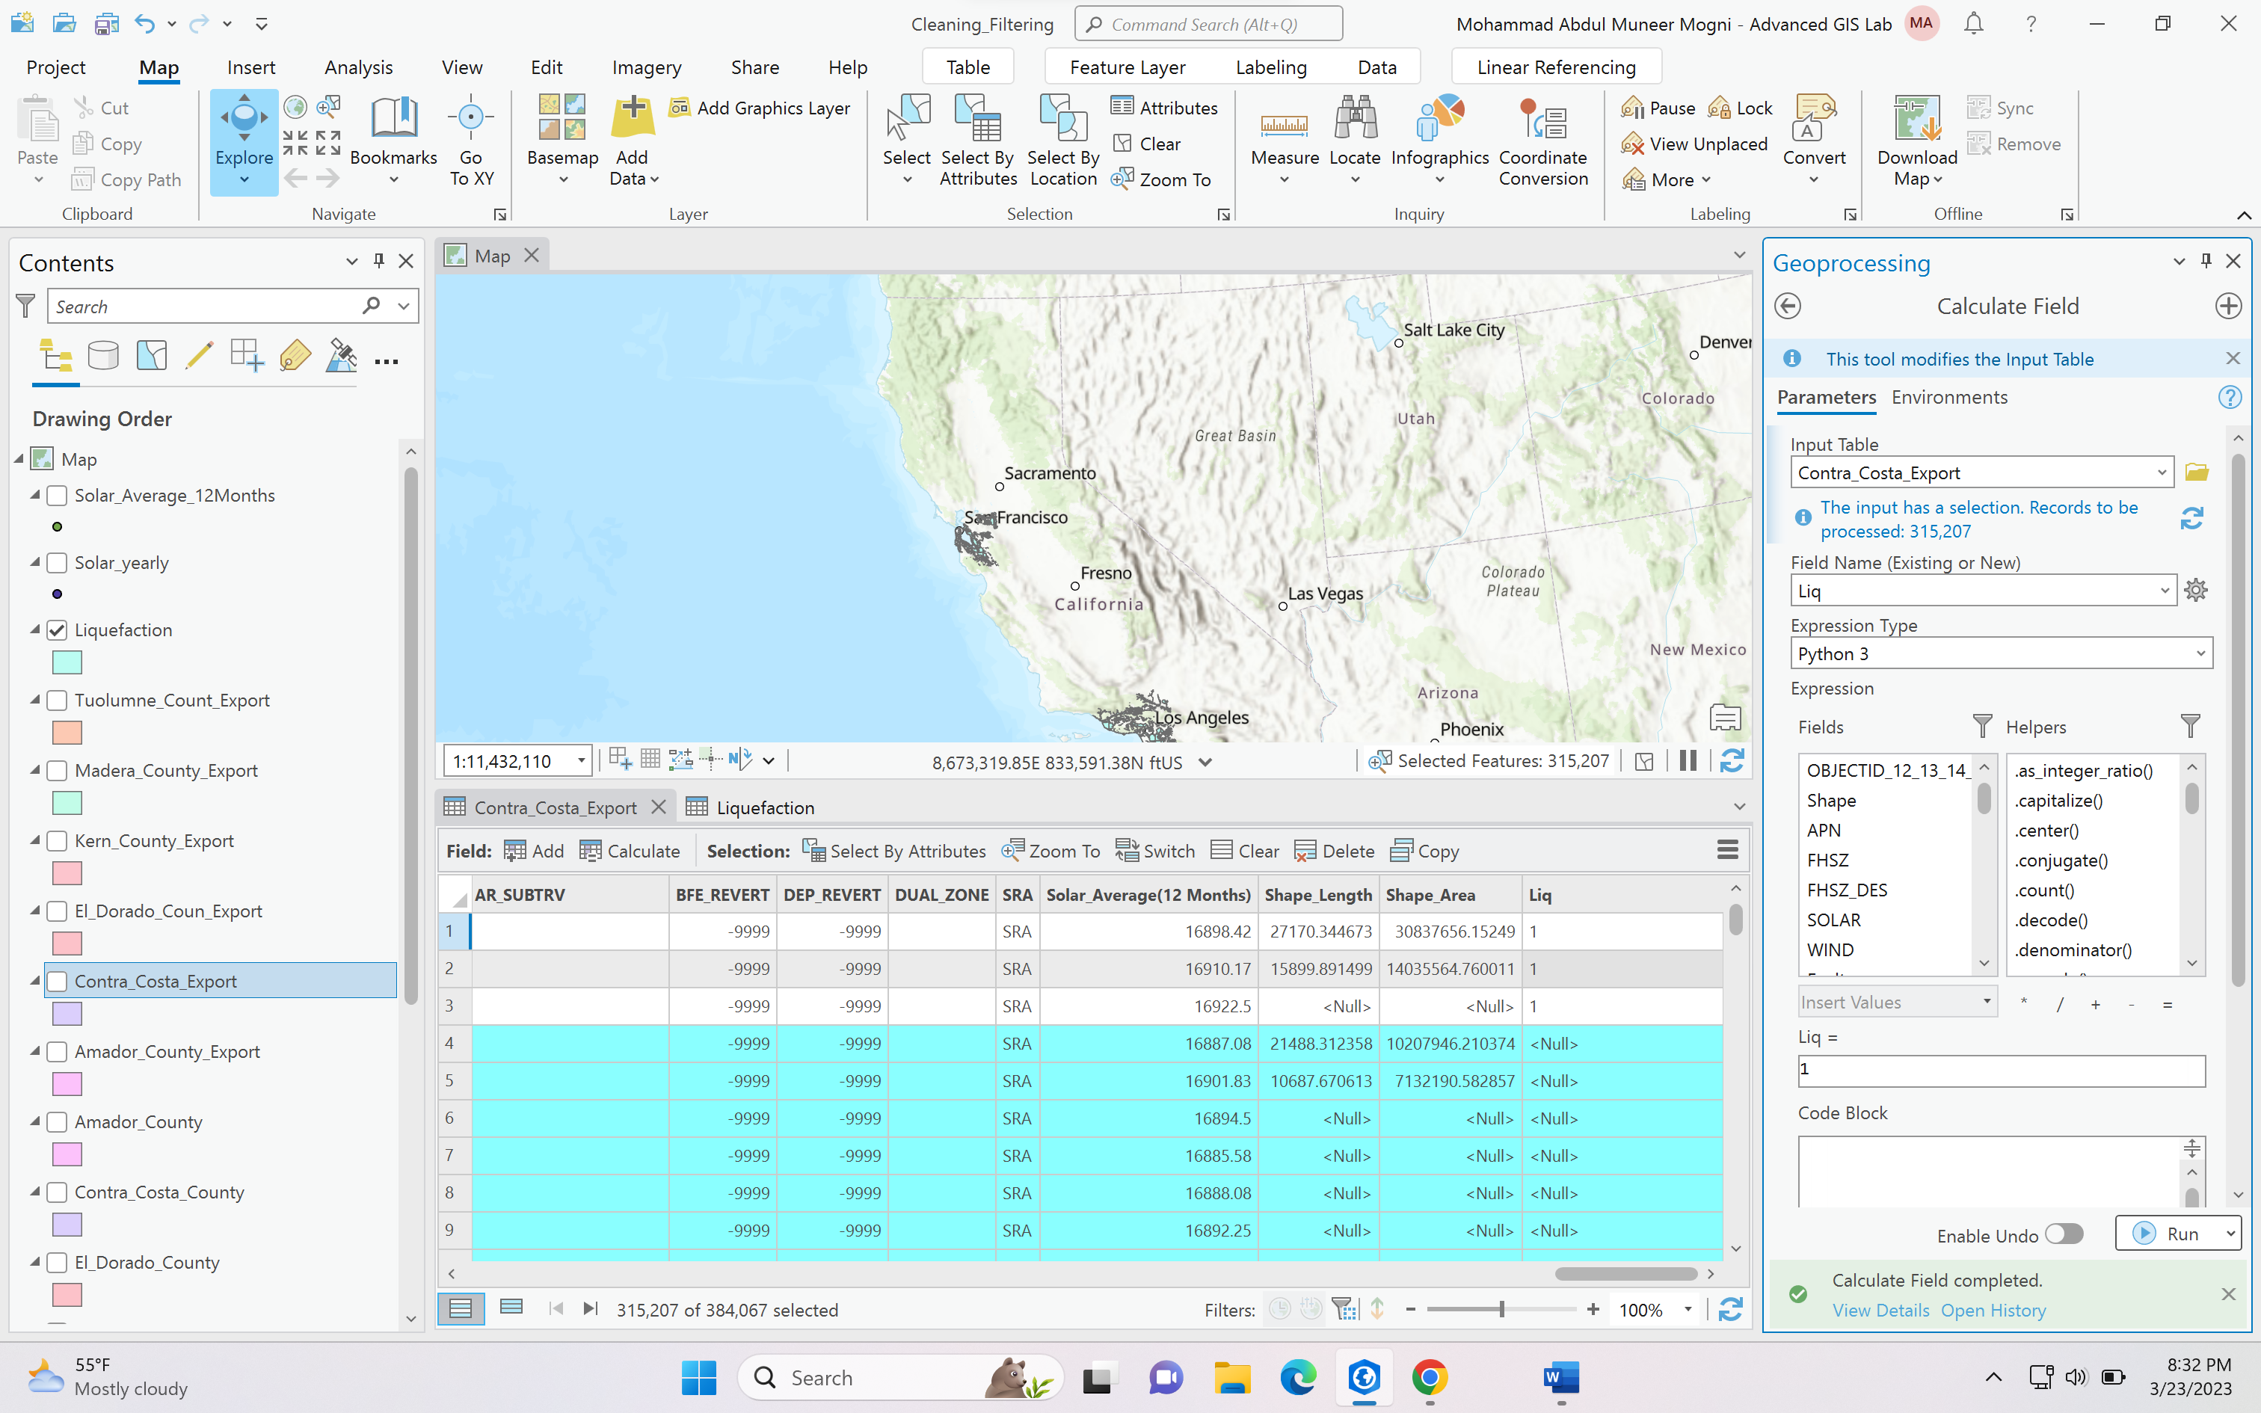

**Now it has selected all the NULL values in Liq table**

**In Calculate field**

**Input Table: Same County**

**Field name: Hazard (Liq)**

**Now the Value will change to 0**

**Liq = 0**

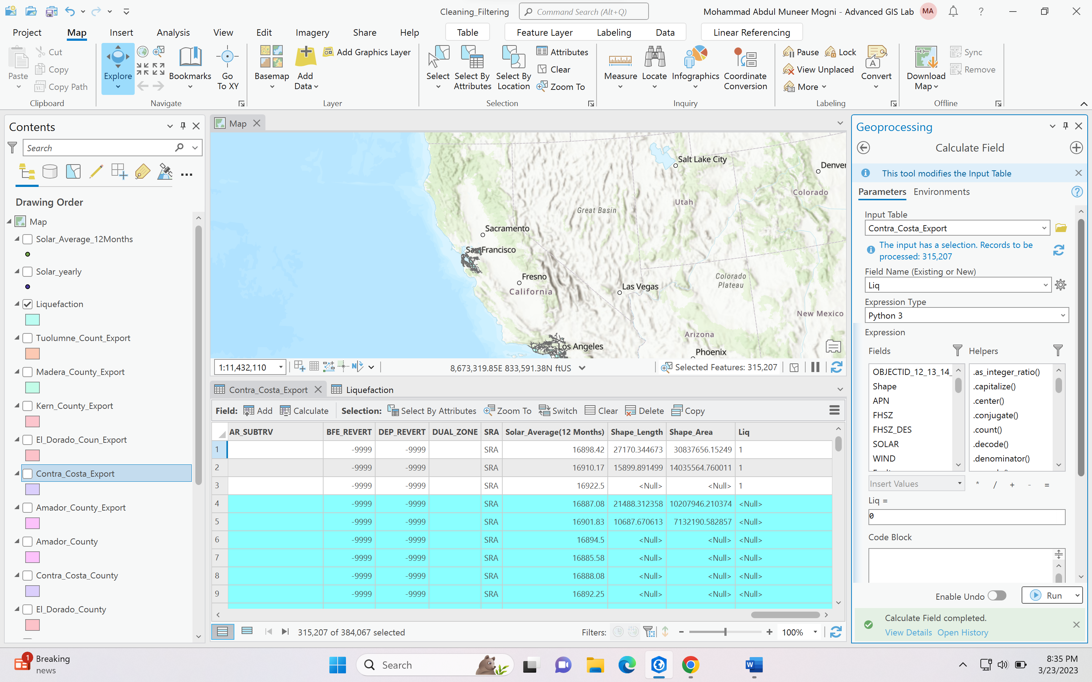

**Now if you see Liq column I have 1s for intersection and 0s which are not intersecting**

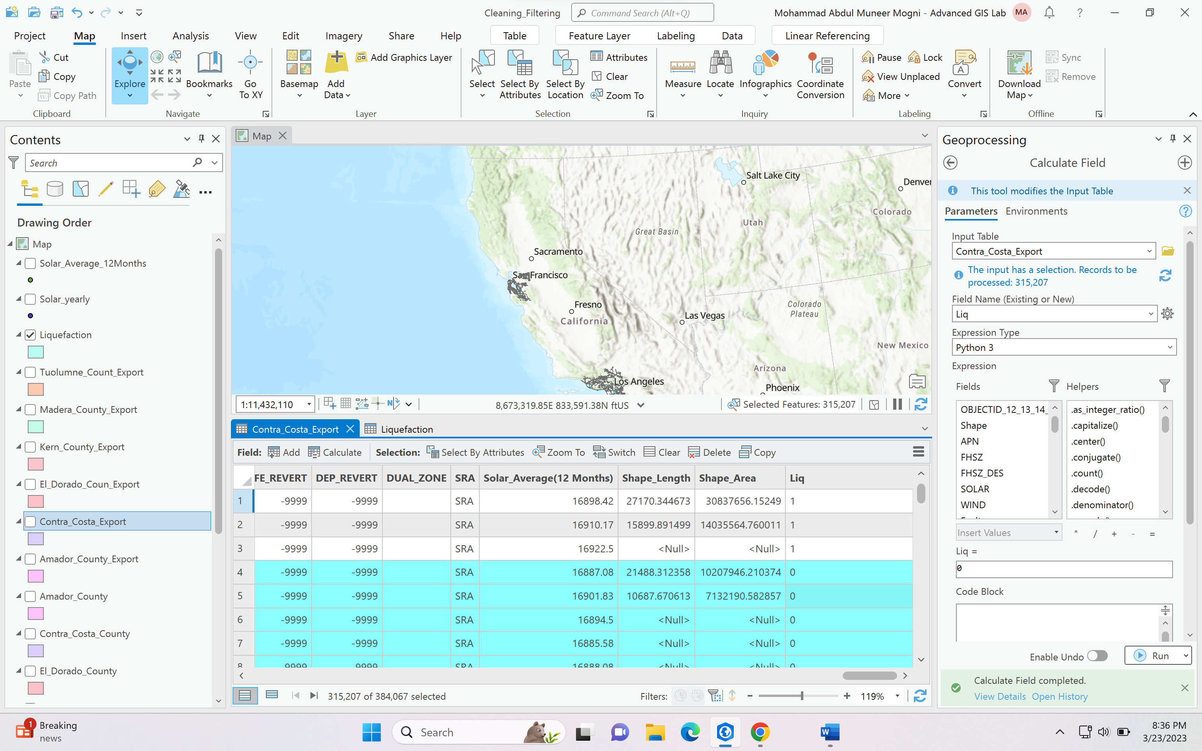

**WIND, SOLAR, DROUGHT AND FLOODING NEEDS TO BE SPATIAL JOINED PLEASE REFER TEMPLATE FOR MORE INFORMATION**